**Practical-6**

**Replication using MongoDb**

**Name-Nishi Patel**

**Roll no.-L003**

**Step 1: Create folder in c drive**

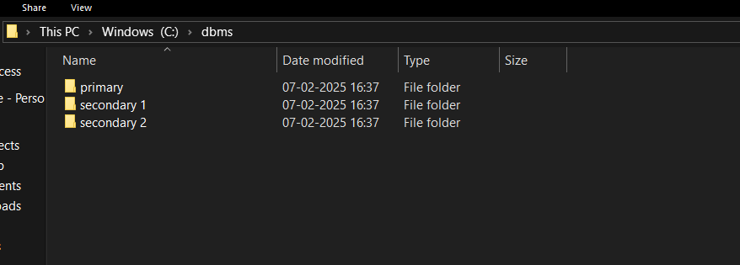

**Step 2: Go to Windows PowerShell ISE>New file(make three of them/ type same command with different port and path)**

Commands:

mongod --port=2717 --dbpath="C:\data\primary" --replSet="test-replica-set"

mongod --port=2727 --dbpath = "C:\data\secondary1" --replSet="test-replica-set"

mongod --port=2737 --dbpath = "C:\data\secondary2" --replSet="test-replica-set"

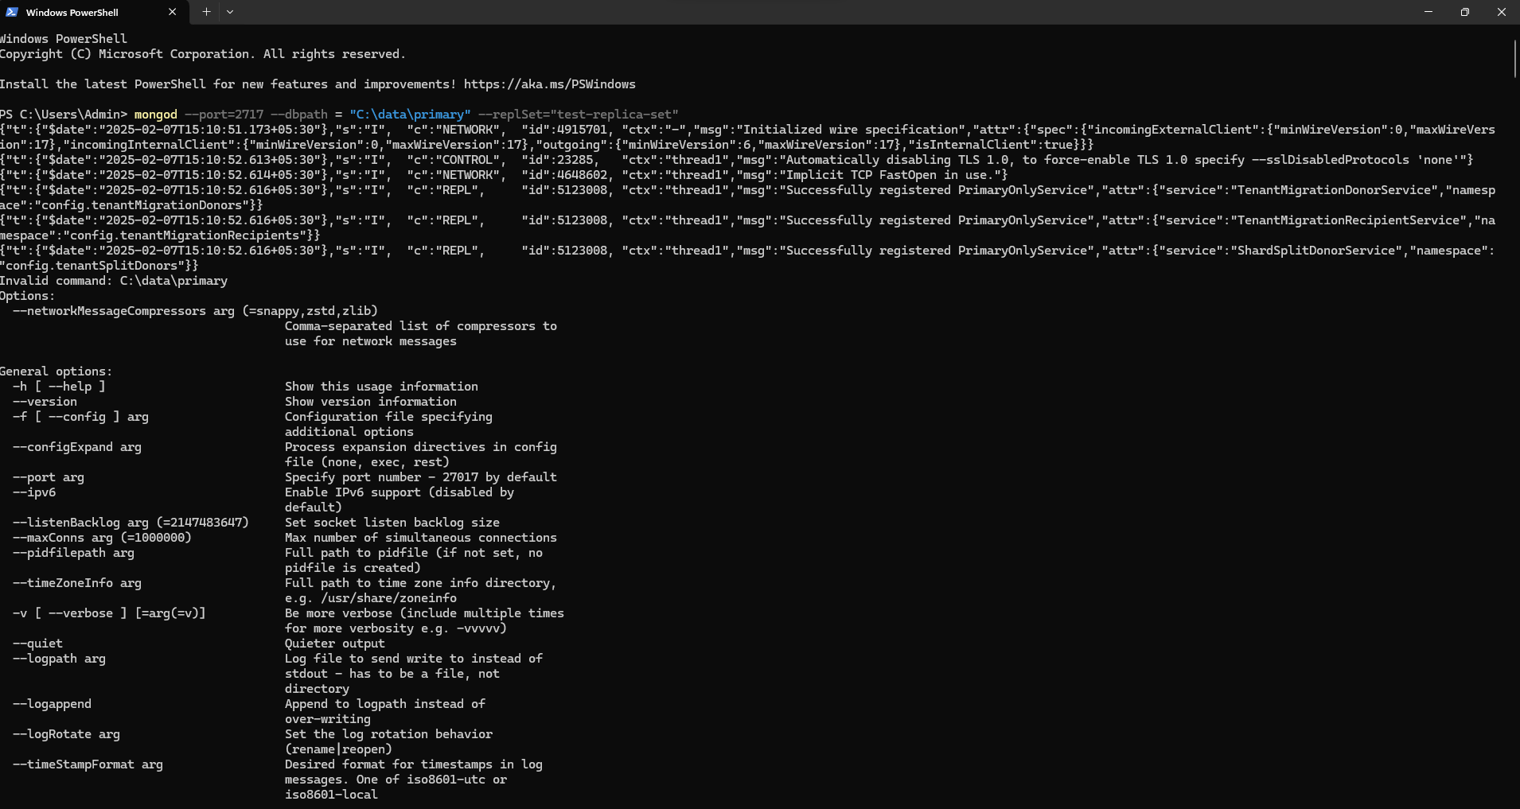

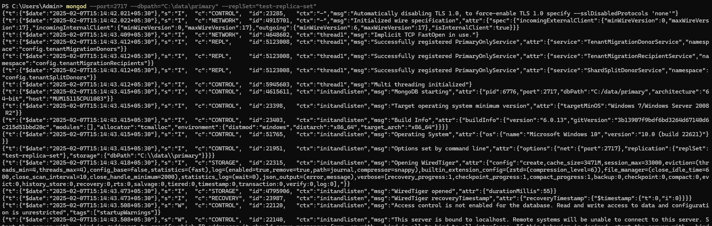

Step 3: New window

Commands:

mongosh --host="localhost:2717" (make new 2 windows with other localhost)

rs.initiate()

rs.add({“host:localhost:2727”});

rs.status()

